EDA Report

- EDA:
Exploratory Data Analysis (EDA) is a crucial initial step in data science projects. It involves analyzing and visualizing data to understand its key characteristics, uncover patterns and identify relationships between variables. EDA helps data scientists to discover patterns, spot anomalies, test hypotheses and check assumptions, providing a better understanding of the dataset.

  - EDA Objectives:
This EDA was performed to check following features of data:
- Discovering the shape and size of data
- Checking the Quality of Data
- Performing descriptive statical analysis
- Checking the Distribution of Data
- Checking relationships between features
- Compare columns by grouping data with respect to species

- About Dataset:
The Iris dataset, also known as Fisher's Iris dataset, is a well-known multivariate dataset introduced by the British statistician and biologist Ronald Fisher in his 1936 paper. It is often used for testing machine learning algorithms and visualizations. The dataset consists of 150 samples from three species of Iris flowers:
- Iris setosa
- Iris versicolor
- Iris virginica
Each sample includes four features(in cm):
- sepal length
- sepal width
- petal length
- petal width

  - Source of data:
Data used to perform EDA for this report have been downloaded from Kaggle from this link: DataSet

- Dataset Overview:

- Shape:
This data set contains 150 rows and 4 columns.

- Column names and Data Types:
Following are Column names and data types of features from Iris data:

Column names | Data types
sepal_length | float64
sepal_width | float64
petal_length | float64
petal_width | float64
species | string

- Unique species values:

Species | Value Count | Value Count in %
Iris-setosa | 50 | 33.33%
Iris-versicolor | 50 | 33.33%
Iris-virginica | 50 | 33.33%

- Class distribution:
Each specie contains 33.333 % of whole data set which shows data is balanced.

- Missing values:
There are NO missing values in data.

- Duplicate Values:
There are following 3 duplicate values in data:

index | sepal_length | sepal_width | petal_length | petal_width | species
34 | 4.9 | 3.1 | 1.5 | 0.1 | Iris-setosa
37 | 4.9 | 3.1 | 1.5 | 0.1 | Iris-setosa
142 | 5.8 | 2.7 | 5.1 | 1.9 | Iris-virginica

  - Duplicate Values Treatment:
Iris data set contains measure of values up to 1 decimal point. Three or even more flowers can have same petal length, sepal length, petal width and sepal width up to this value. So, we don’t need to drop or replace these duplicated values.

- Invalid Values:
There are no invalid values in this data set which means data doesn’t have NO negative for length.

- Descriptive Statistics:

 | sepal_length | sepal_width | petal_length | petal_width
count | 150.000000 | 150.000000 | 150.000000 | 150.000000
mean | 5.843333 | 3.054000 | 3.758667 | 1.198667
std | 0.828066 | 0.433594 | 1.764420 | 0.763161
min | 4.300000 | 2.000000 | 1.000000 | 0.100000
25% | 5.100000 | 2.800000 | 1.600000 | 0.300000
50% | 5.800000 | 3.000000 | 4.350000 | 1.300000
75% | 6.400000 | 3.300000 | 5.100000 | 1.800000
max | 7.900000 | 4.400000 | 6.900000 | 2.500000

This data shows that:
- Sepal length has greatest maximum value among all features.
- Petal length has greatest STD (standard deviation) which shows values for it are more diverse.

- Skewness:
Features | Skewness Value
Sepal length | 0.31
Petal length | -0.27
Sepal width | 0.33
Petal width | -0.10

Observation:
It means that data for sepal length and width have tails on right side in graph as they have positive skewness value and data for petal length and width have tail on left side as they have negative skewness value. This observation can be verified by following graphs:

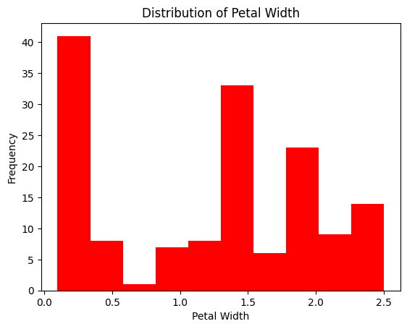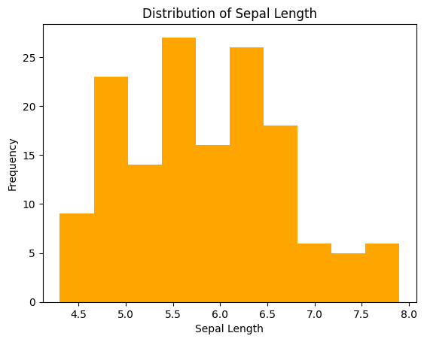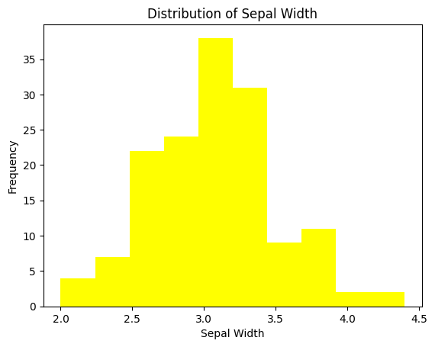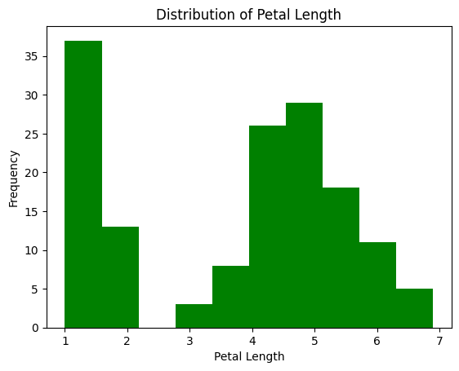

- Co-relation matrix & heat map:
The correlation matrix and heatmap show how closely the different flower measurements are related to each other. For example, flowers with longer petals usually also have wider petals. Sepal length is also related to petal size, while sepal width does not show a strong connection with the other measurements. In simple words, it helps us understand which flower features tend to increase or decrease together. The following correlation matrix and heatmap show Petal length and petal width have a very strong positive correlation, while sepal length also has a strong relationship with petal measurements. Sepal width has a weaker correlation with the other features. This helps us understand which features are closely related and useful for distinguishing Iris species.

  - Matrix:
 | sepal_length | sepal_width | petal_length | petal_width
sepal_length | 1 | -0.109369 | 0.871754 | 0.817954
sepal_width | -0.109369 | 1 | -0.420516 | -0.356544
petal_length | 0.871754 | -0.420516 | 1 | 0.962757
petal_width | 0.817954 | -0.356544 | 0.962757 | 1

  - Heat Map:
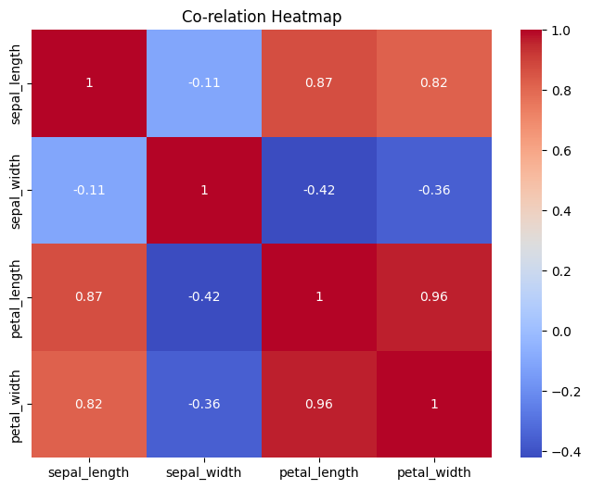

- Outliers:
When we find outliers that are outside Lower Bound = Q1 − 1.5 × IQR & Upper Bound = Q3 + 1.5 × IQR we get following result:
Features | No. of outliers
sepal_length | 0
sepal_width | 4
petal_length | 0
petal_width | 0

This can also be verified b following box plot:
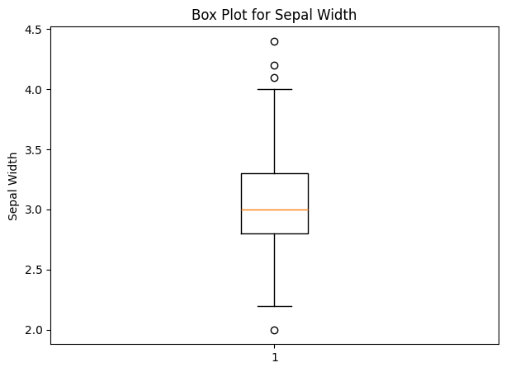
The blank circles (3 on top and 1 under box) are outliers.

- Pair Plot graphs:
The pair plot of the Iris dataset shows how the four flower measurements—sepal length, sepal width, petal length, and petal width—are related to each other for the three Iris species. The different colors make it easy to see that Iris-setosa (blue) is clearly different from the other two species, mainly because it has much smaller petals. Iris-versicolor (orange) and Iris-virginica (green) are more similar, so some of their points overlap, but virginica generally has longer and wider petals.
The plot also shows that petal length and petal width have a strong relationship: flowers with longer petals usually have wider petals. Sepal length also tends to increase as petal size increases, although this relationship is not as strong. Sepal width is more scattered, meaning it does not provide as clear a distinction between the species.
Overall, the pair plot suggests that petal length and petal width are the most useful measurements for identifying the Iris species. Setosa can be easily distinguished, while versicolor and virginica require the petal measurements to be separated more clearly. The graphs on the diagonal show how the values of each measurement are distributed for the three species. Following graphs prove all these observations:
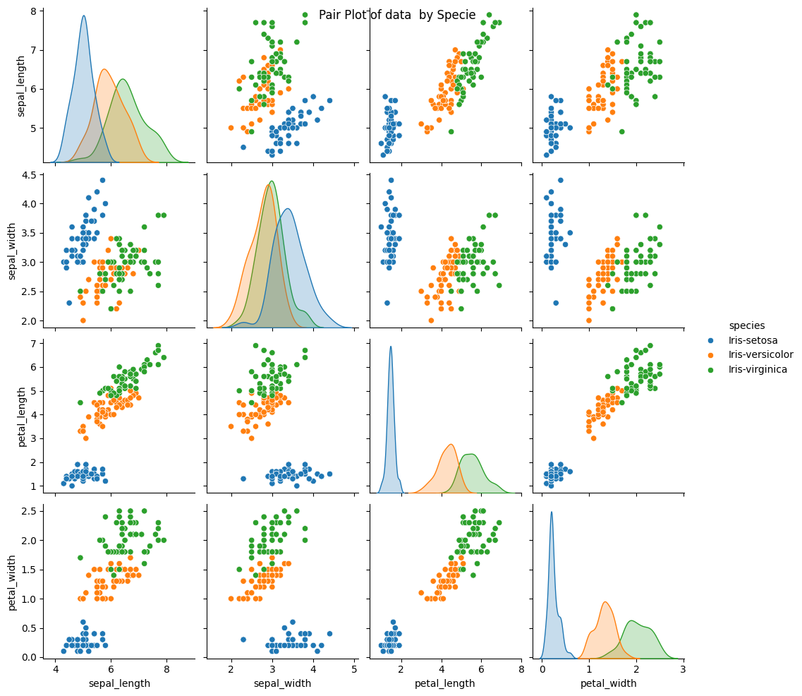

- Distribution by grouping into species:
Petal Length
The petal length graph shows a clear difference between the three Iris species. Iris-setosa has the shortest petals, Iris-versicolor has medium-sized petals, and Iris-virginica has the longest petals. This means petal length is a very useful measurement for telling the species apart. A few unusual values can also be seen as small circles, which are considered outliers.
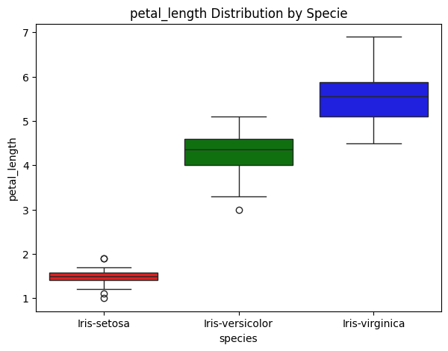
Petal Width
The petal width graph shows a similar pattern. Iris-setosa has very narrow petals, Iris-versicolor has wider petals, and Iris-virginica has the widest petals. The groups are clearly separated, showing that petal width is also a strong feature for identifying the different species. Setosa has a couple of unusual values shown as outliers.
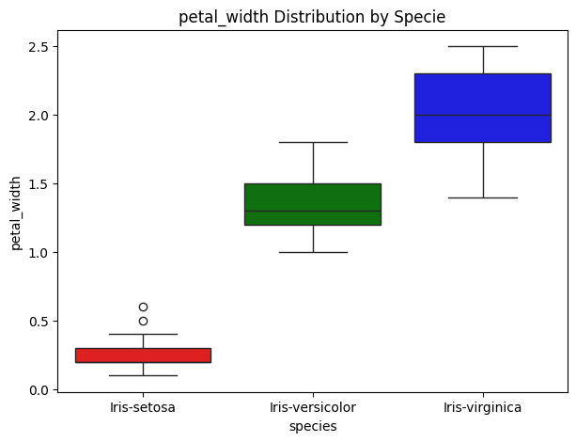
Sepal Length
The sepal length graph shows that Iris-setosa generally has the shortest sepals, Iris-versicolor has medium-length sepals, and Iris-virginica has the longest sepals. However, the ranges of the species overlap more than they do for petal measurements. There is also one unusual value visible for virginica.
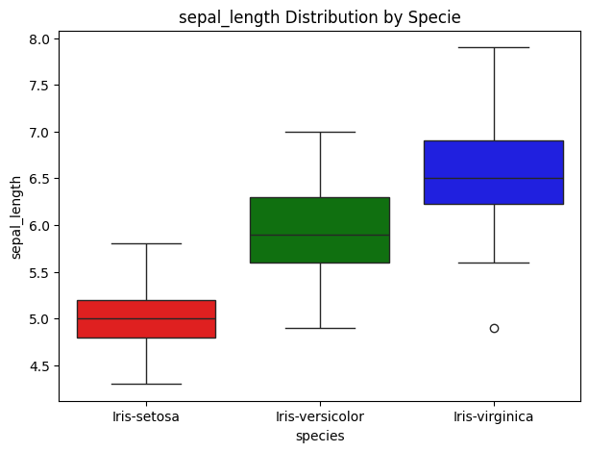
Sepal Width
The sepal width graph is different from the others. Iris-setosa generally has the widest sepals, while Iris-versicolor has the narrowest, and Iris-virginica falls mostly in between. The values show more variation, and virginica has a couple of unusual values. This suggests that sepal width is less useful for clearly separating the three species compared with petal length and petal width.
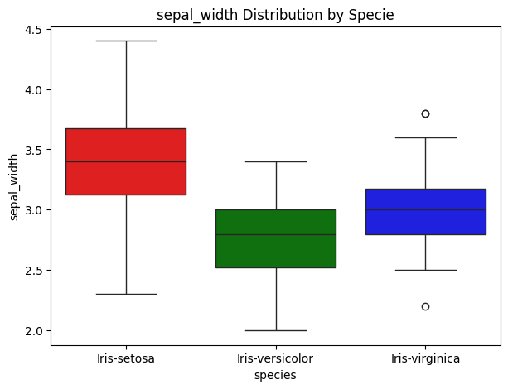

- Key Findings:
- Dataset contains 150 records with 4 numeric features (sepal length, sepal width, petal length, petal width) and 1 categorical feature (species), perfectly balanced across 3 species (50 each)
- No missing values found
- 03 duplicate records identified
- No invalid or impossible values detected in any feature
- Petal measurements show much greater variability (std dev ~1.77 for petal length) than sepal measurements (std dev ~0.44 for sepal width)
- Sepal length and sepal width are mildly right-skewed
- petal length and petal width are mildly left-skewed
- Petal length's overall distribution is bimodal (having 2 Maximas)
- Outliers exist only in sepal width (4 detected via IQR method); no outliers in the other three features
- Petal length and petal width are extremely strongly correlated (0.96)
- Petal length and sepal length are strongly correlated (0.87)
- Sepal width behaves almost independently, showing weak negative correlation with all other features
- Petal length vs. petal width is the strongest visual separator between the three species
- Setosa is completely distinguishable from the other two species based on petal size alone (avg petal length 1.46 cm vs. 4.26 cm and 5.55 cm)
- Versicolor and Virginica overlap somewhat but remain distinguishable, particularly via petal width (1.33 cm vs. 2.03 cm average)
- Mean and median values are close across most species/feature groups, indicating fairly symmetric distributions within each species.

- Appendix:
Notebook link:

Libraries used:
- Numpy
- Pandas
- Matplotlib
- Seaborn

- Author:

- Muhammed Sudais Amin
- [Sudais-apk]: Git hub Link
- [Muhammad Sudais Amin]: Muhammad Sudais Amin | LinkedIn

